A Template and Guide for the Creation of a Full Paper Submission to PAQS Congress 2024: Insert Paper Title Here

Author1 (corresponding author), Author1 email address

*Author1 affiliation, Author1 Country*

Author2, Author2 email address

*Author2 affiliation, Author2 Country*

**Abstract**

Please prepare your paper following this template. Abstracts cannot exceed 300 words, clearly stating the aim, objectives, how data was obtained, the principal results and major conclusions. The submitted file should be in .doc or .docx format. .pdf is not acceptable. All abstracts must be written in English. The abstract should be written in a single paragraph format. The guidelines for writing the abstract is as follows. Limit the first 2 sentences of the abstract to explain the background or context. One sentence on the aim/objective/purpose of the paper. One to two sentences on the method of obtaining data for the paper. Three to four sentences on the main findings, and implications of the findings. Two sentences on contribution to knowledge and practice. One to two sentences on conclusion and recommendations. One paper cannot have more than 5 authors. It is the corresponding author’s responsibility to submit a correct abstract. Any error in spelling, grammar or scientific fact will be reproduced as typed by the author. Correspondence regarding the paper such as confirmation of submission, notification of acceptance or rejection and instructions for presentation will only be sent to the corresponding author. It is his/her responsibility to forward the information to all co-authors. The presenting author is required to register for the Congress and pay the registration fee as a condition of presenting the paper. Each registered participant is allowed a maximum of 2 presentations/papers subject to the approval of the PAQS Congress 2024 committee.

**Keywords**

Up to five keywords, in lower case, alphabetical order, separated by commas, finishing with full-stop.

# **Introduction**

The Introduction section provides the background and context of the paper. Explain the rationale for paper, what problems need to be solved and knowledge gap. Your paper must state the overall aim of the paper and the specific objectives to fulfil the overall aim.

Your paper must be divided into sections, and each section to be numbered and provided with a subtitle. The subtitles provided throughout this template are suggestions to authors only. Authors may use subtitles that fit their paper.

Author needs to describe in general how data was obtained to satisfy the aim and objectives. The findings and contributions of the paper should. It is also a good practice to identify who will or is expected to benefit from the findings.

# **Literature Review**

The literature review should flow from general to specific. There is no strict set of rules that prescribes the numbers of references that should be presented. The referencing system used should be the Harvard system. Authors can find a complete guide to the Harvard referencing system through Taylor & Francis at, <https://www.tandf.co.uk//journals/authors/style/reference/tf_X.pdf>. For in-text citation, please use the following format: (Ling 2000) for single author, (Ling and Gan 2020) for two authors and (Ling et al 2022) for three or more authors. In the case of more than one article by the same first author is referenced, show it as (Ling et al 2021; 2022).

Even though it is called the literature review section, the actual title of section 2 does not have to be “Literature Review”. It can be other titles that might better represent the content of this section and the principles of the paper.

## **Level 2 Sub-sections**

Starting from section 2 onwards (except for section 6 References), Level 2 subsections can be added whenever necessary by selecting Heading 2 or Heading 3 as appropriate. Note that subsection groups should be a minimum of 2 if used; if you only have 1 subsection then you do not need a subsection.

### *Level 3 Sub-sections*

Authors are not advised to use more than three levels of subsections’ nesting.

# **Methodology**

The methodology of the paper should be explained. For example how data was collected and analysed. Note that not all papers will have a formal research methodology section as some papers might be critical reviews or practice oriented papers.

# **Findings and Discussion**

In this section, authors should discuss all the findings followed by an analytical discussion of the findings. This can be done, for instance, by critically demonstrating how the findings relate to the current body of knowledge in or relevant to the field of investigation. Recommendations may be offered. This section is the main contribution of the paper.

Tables and figures may be used within sections 2, 3, 4, and/or 5 to better illustrate the points made or to better present data. For tables, the table caption should be numbered (Table 1 <title>, Table 2 <title> …) and positioned at the top of the table. One space should be added after the table. The table should be centred in the page using Times New Roman 11-point font to set it from the main text with title above the table. Figures should be no more than 12 cm wide, centred with Figure number and title placed below the figure.

Table 1. Construction output

| Q | 2020 ($ in million) | 2019 ($ in million) | 2018 ($ in million) | 2017 ($ in million) | YoY change (2020 vs 2019) | YoY change (2020 vs 2018) | YoY change (2020 vs 2017) | Average YoY change |
| --- | --- | --- | --- | --- | --- | --- | --- | --- |
| Q1 | 7,403.46 | 7,085.75 | 6,741.56 | 7,545.46 | 4.5% | 9.8% | -1.9% | 4.1% |
| Q2 | 3,199.28 | 6,758.00 | 6,471.96 | 6,776.64 | -52.7% | -50.6% | -52.8% | -52.0% |
| Q3 | 3,360.43 | 6,950.00 | 6,568.39 | 6,642.2 | -51.6% | -48.8% | -49.4% | -50.0% |
| Q4 | 5,776.87 | 7,506.00 | 6,817.37 | 6,946.87 | -23.0% | -15.3% | -16.8% | -18.4% |

Note: Q= quarter; YoY= Year on Year; Source: Data for 2017 to 2020 from BCA (2021c)

Figures should be numbered and given titles, and placed below the figure.

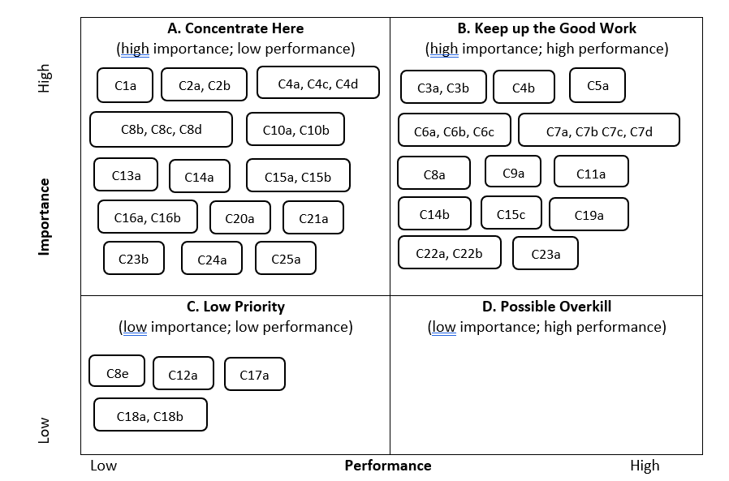

Figure 1. Importance-performance analysis matrix of QSs’ skills for Industry 4.0

# **Conclusions**

In this section, the author should summarise the whole discussion presented in the paper. The main findings and who can benefit from the results should be provided.

# **Acknowledgement**

In some cases, it is necessary for the author to acknowledge that this paper is a part of a larger research project, acknowledging the funding contributed by a certain funding agency, or simply acknowledging contributions of other colleagues who are not included in the authorship of this paper. If no acknowledgement is necessary, this section should be deleted from the paper.

# **References**

Authors can find a complete guide to the Harvard referencing system through Taylor & Francis at, <https://www.tandf.co.uk//journals/authors/style/reference/tf_X.pdf>. Common references are below.

Author1, Initials., Author2, Initials., and Author3, Initials., Year. Article Title. *Journal Title*, Volume (issue), 11-25.

Author1, Initials., Author2, Initials., and Author3, Initials., Year. *Book title*. Place: Publisher.

Author1, Initials., Author2, Initials. and Author3, Initials., Year. Article Title, In: Editor(s), *Conference Proceeding*, Dates and Place of Conference. Place: Publisher, 21-30.

Ling, F.Y.Y., and Gan M.J.S., 2020. Mastery of fundamental concepts based on students' learning approach in flipped classrooms. *Journal of Civil Engineering Education* 146(2), 01. <https://ascelibrary.org/doi/10.1061/%28ASCE%29EI.2643-9115.0000011>

Ling, F.Y.Y., Zhang, Z., and Yew, A.Y.R., 2022. Impact of COVID-19 pandemic on demand, output and outcomes of construction projects in Singapore. *Journal of Management in Engineering*, 38(2). <https://doi.org/10.1061/(ASCE)ME.1943-5479.0001020>

# **Page Setup**

1. Paper size is A4

2. Margin is as indicated in this template

3. Page Limitation: Author(s) are allowed to submit a final paper of up to **15 pages** only

**All fonts in the full paper must be in TIMES NEW ROMAN only**